- 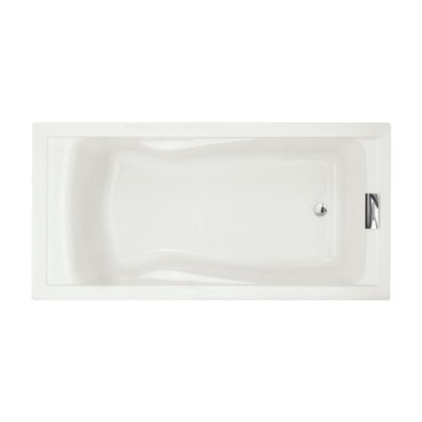

American Standard 7236V002.020 Evolution Bathtub with Form Fitted Back Rest, White

List Price: | $1,016.00
Price: | $528.32 & FREE Shipping.
You Save: | $487.68 (48%)
In Stock.

- Acrylic with fiberglass reinforcement
- Dual molded-in armrests
- Reversible drain outlet
- Accommodates drop-in or undermount installations

- 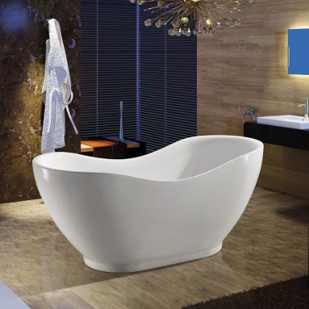

AKDY Bathroom Oval White Color FreeStanding Acrylic Shower Soaking Bathtub AZ-F290

List Price: | $2,999.00
Price: | $1,099.99 + $54.49 shipping
You Save: | $1,899.01 (63%)
In stock on May 31, 2016.
Order it now.
Estimated Delivery Date: June 6 - 20 when you choose Standard Shipping at checkout.
- Material: Acrylic, (Bathtub And Faucet Combo Available)
- The Fittings Which You Need To Install The Bathtub are included
- Outside dimensions : 66.93" Length X31.50" Width X29.92" Height
- The water depth from bottom to overflow is 21.5"
- 1 year Parts Warranty against manufacture defects

- 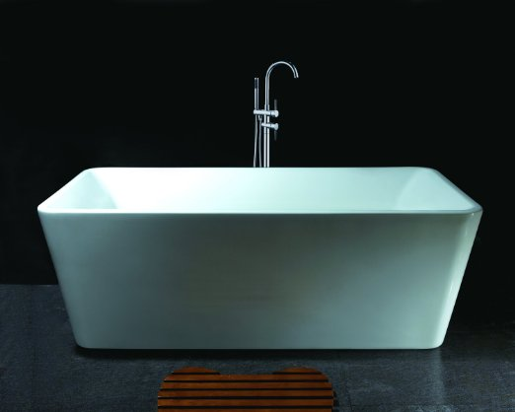

AKDY Bathroom White Color FreeStand Acrylic Bathtub And Faucet AZ-F245-WFB

List Price: | $2,999.00
Price: | $1,108.00 + $82.99 shipping
You Save: | $1,891.00 (63%)
In stock on May 30, 2016.
Order it now.
Estimated Delivery Date: June 3 - 17 when you choose Standard Shipping at checkout.
- Material: Acrylic
- The Fittings Which You Need To Install The Bathtub are included
- 1 year Parts Warranty against manufacture defects
- Outside dimensions : 66.93" Length X33.46" Width X24.41" Height
- The faucet is included

4Moms Infant Tub, White
- 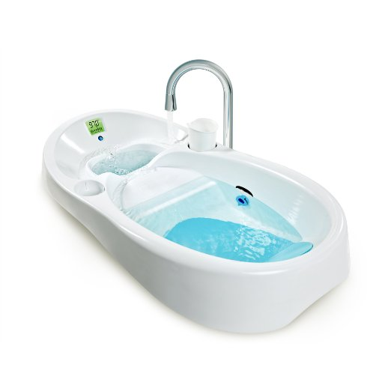

About the Product
- Side drains allow dirty water to flow out while clean water flows in
- Built-in digital thermometer with a color-coded temperature display
- Fits most single and double sinks
- Includes a rinse cup and an integrated rinse cup holder

- 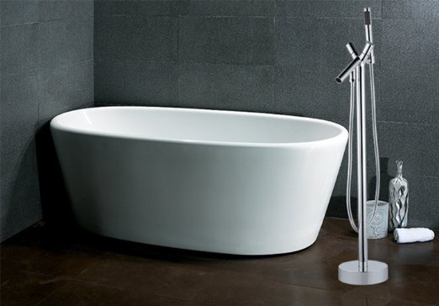

AKDY Bathroom White Color FreeStand Acrylic Bathtub And Faucet AZ-F248-WFC

List Price: | $3,000.00
Price: | $1,206.00 + $94.49 shipping
You Save: | $1,794.00 (60%)
In stock on May 30, 2016.
Order it now.
Estimated Delivery Date: June 3 - 17 when you choose Standard Shipping at checkout.

- Material: Acrylic
- The Fittings Which You Need To Install The Bathtub are included
- 1 year Parts Warranty against manufacture defects
- Outside dimensions : 66.93" Length X29.53" Width X23.62" Height

